NISHARUGHAAN

PARAMAJOTHY

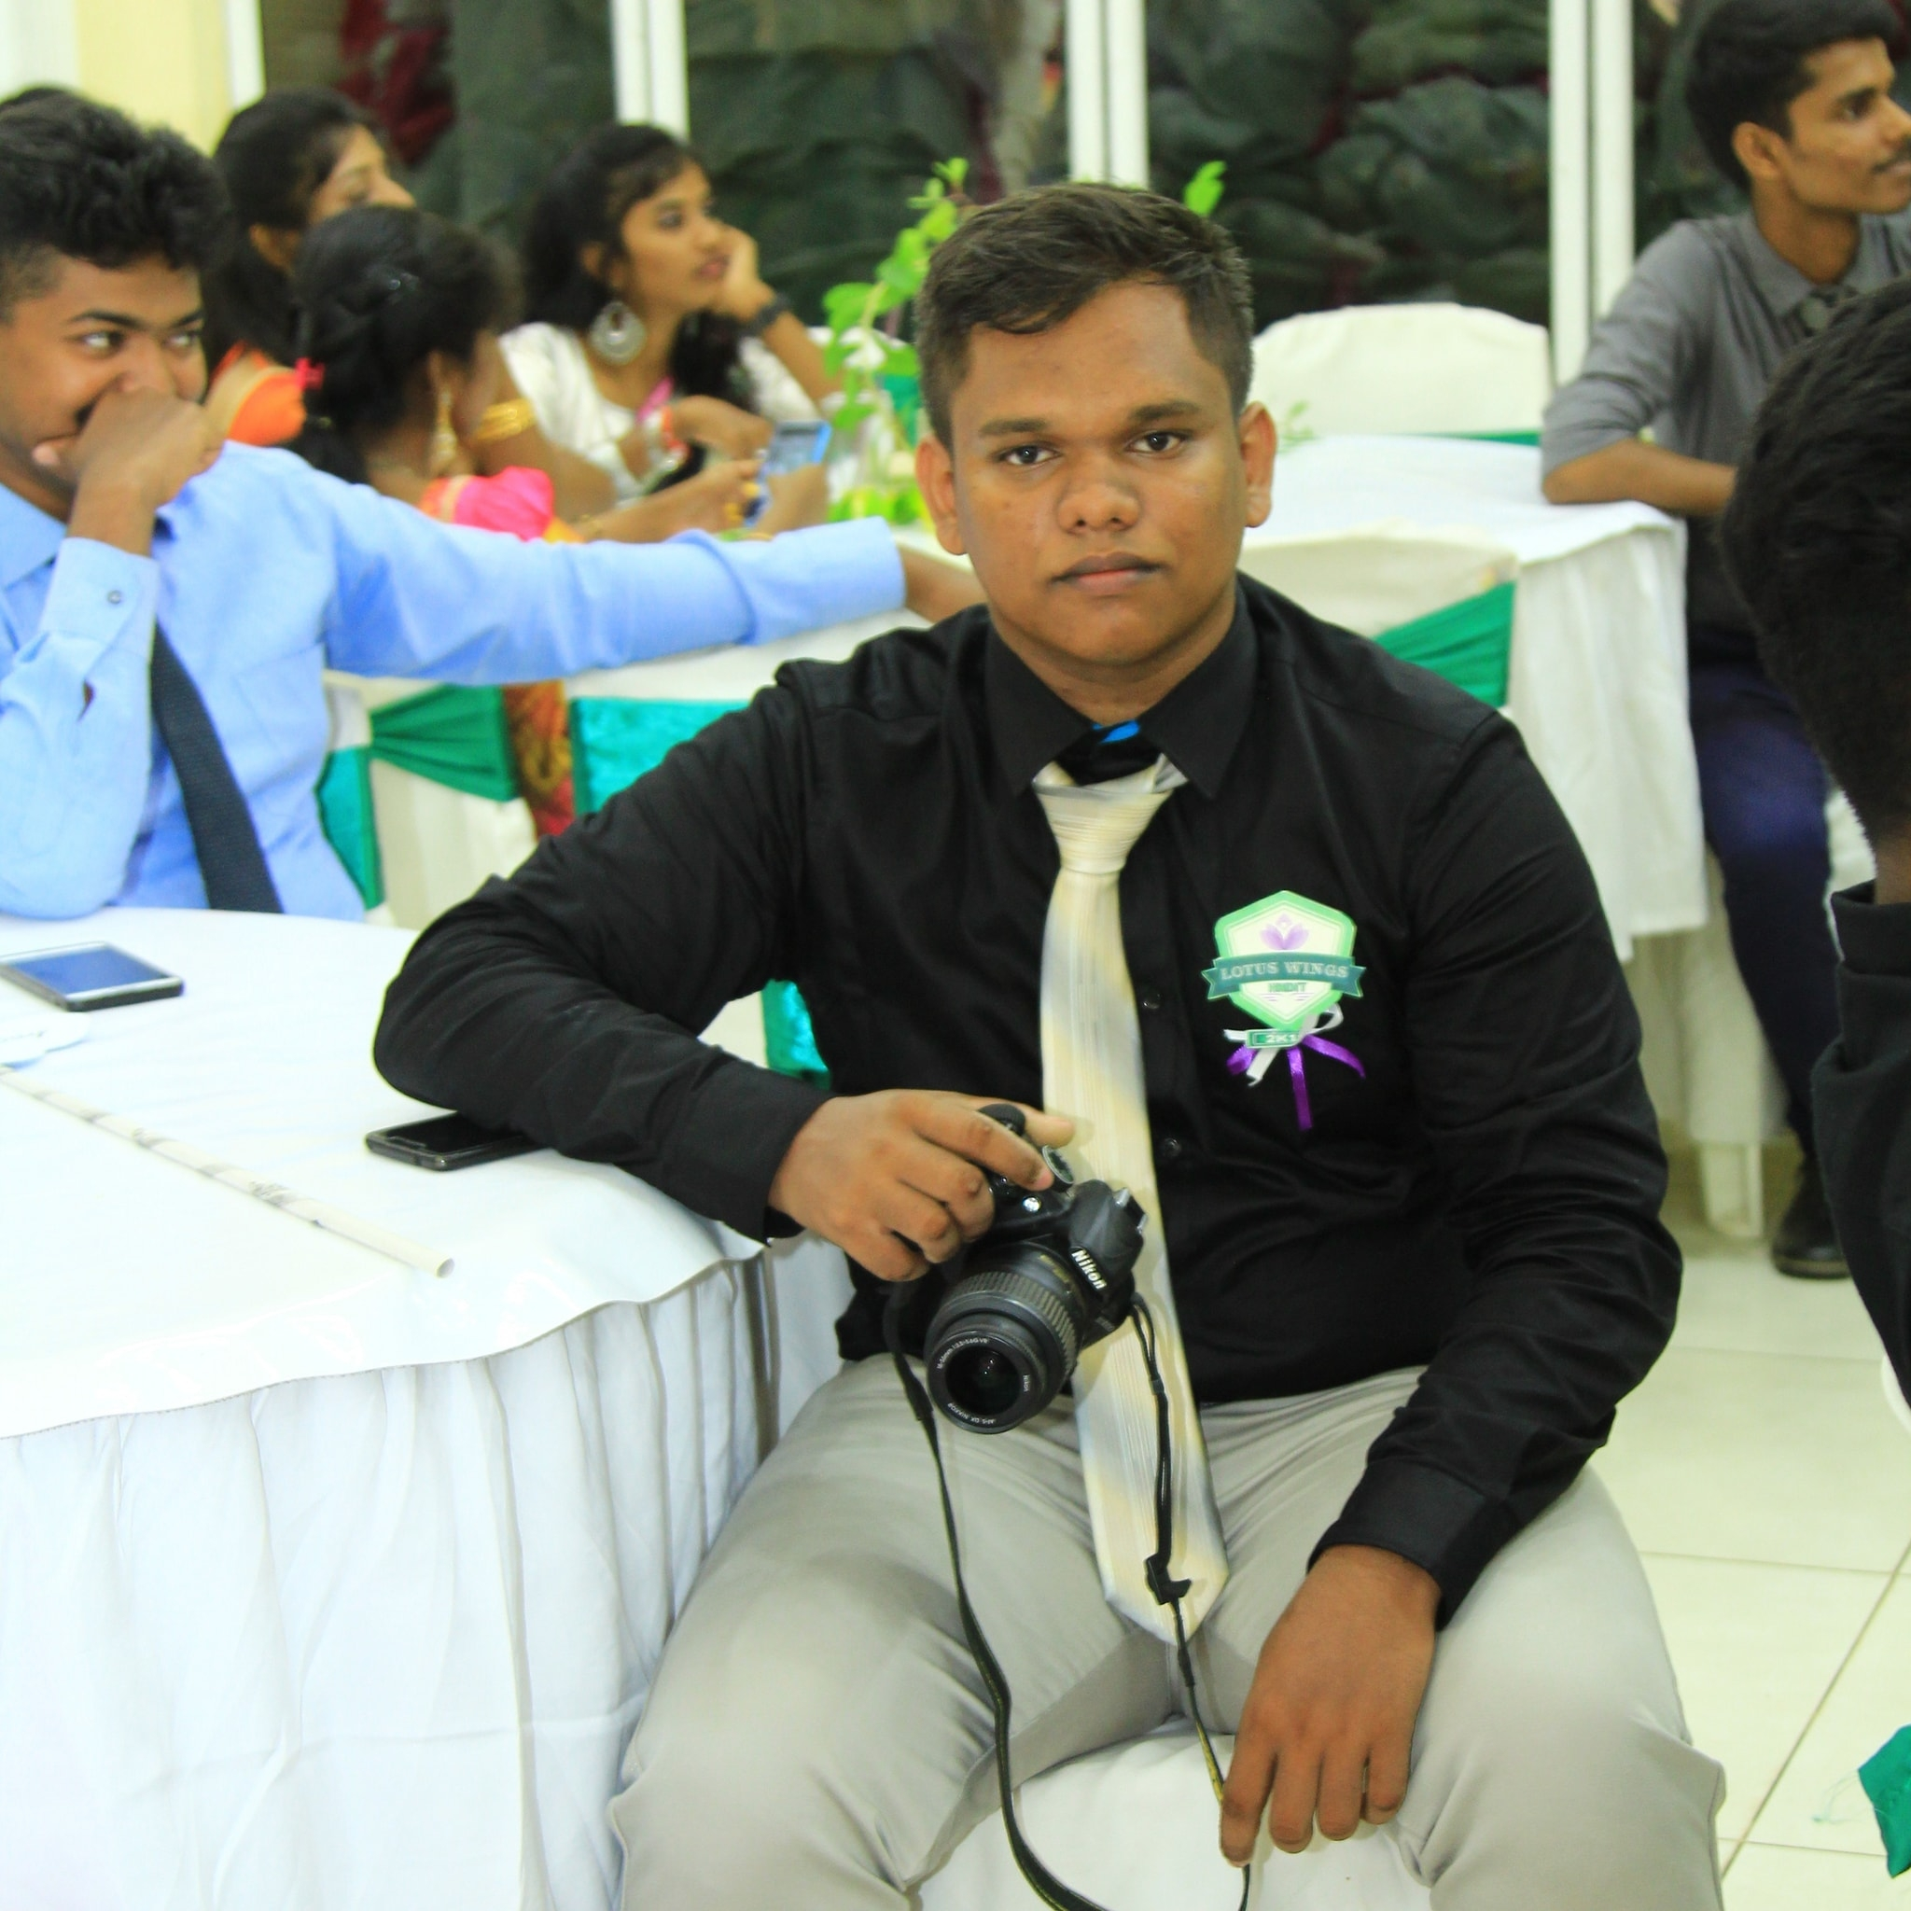

Contact

**Address:**

No.1, St. Patrick’s Road, Jaffna.

**Phone:**

+94 (0)76 454 1258

**Email:**

Nisharu99@gmail.com

Languages

Tamil.

English.

Summary

Web Developer & Content Creator specializing in front end development & Video, Photo editing. Experienced with Video editing and Photo editing projects and small websites. Learnt HTML5, PHP, JavaScript, CSS, MySQL.

Skill Highlights

|  |  |
| --- | --- |
| * Project management * Strong decision maker * Complex problem solver | * Creative design * Innovative * Service-focused |

Education

Higher National Diploma: **Information Technology** - 2022

**Advanced Technical Institute**, Jaffna.